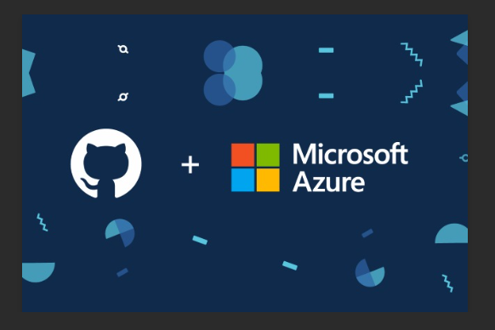

## USES OF AZURE:

## 1.Familiarity of Windows

Azure is based on Windows, so you can write applications in the same programming languages you've used for Windows apps: Visual Basic, C++, C#, etc. You can also use familiar tools such as Visual Studio, along with ASP.NET and other familiar Windows technologies.

## 2.Azure SDK

Microsoft provides the Windows Azure software development kit (SDK), which includes a version of the Azure environment you can run on your own computer. It's called the Windows Azure Development Fabric, and it includes the Azure agent and storage. You can work locally when developing and debugging an application and then move it to the cloud.

**3.Cost benefits and pricing model**

The cost of creating, testing, debugging, and distributing Web-based applications goes down because you have to pay only for the computer processing time and storage space you need at a given time.

## 4: Support resources

Because Azure uses the same familiar tools and technologies as other Windows platforms, you can take advantage of the well-established support structure within Microsoft and company-provided resources, such as TechNet and MSDN

**Azure App Services:**

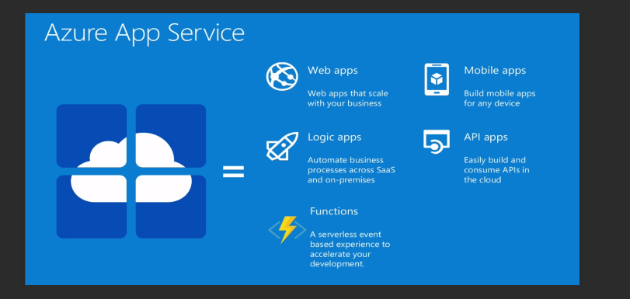

**CREATING AZURE ACCOUNT(FREE-TIER):**

* The following steps give us a clear picture of how to create an azure account

i.e FREE TIER.

**STEP-1:**

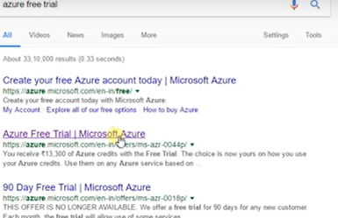

**STEP-2:**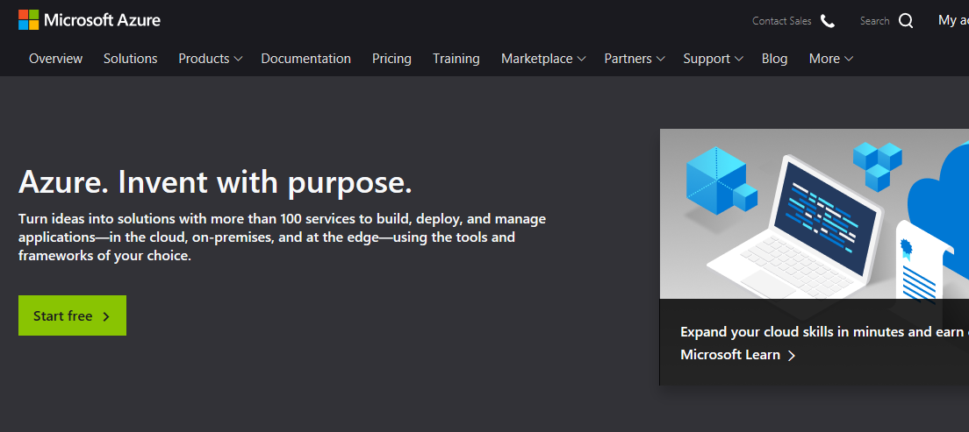

**STEP-3:**

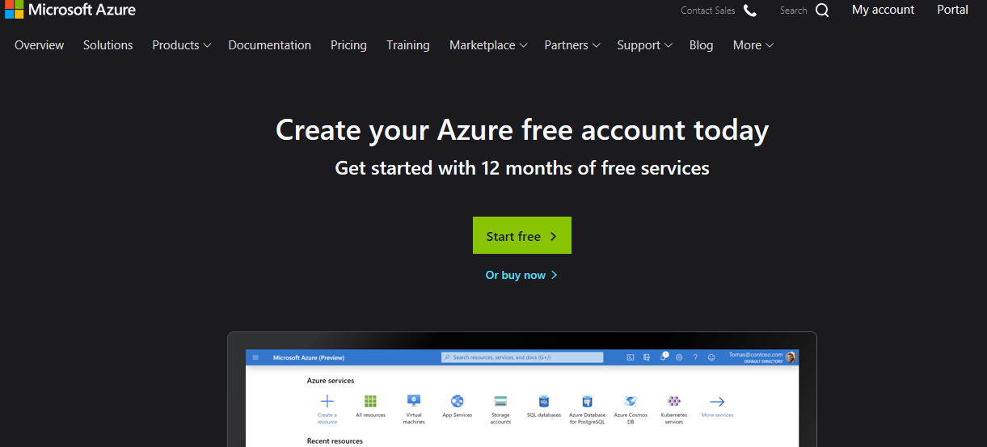

**STEP-4:**

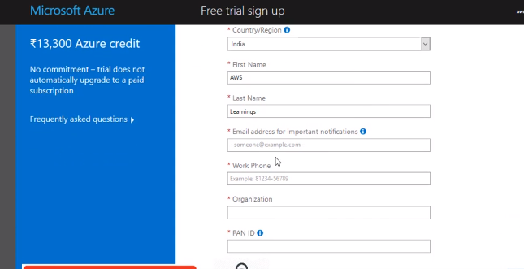

**STEP-5:**

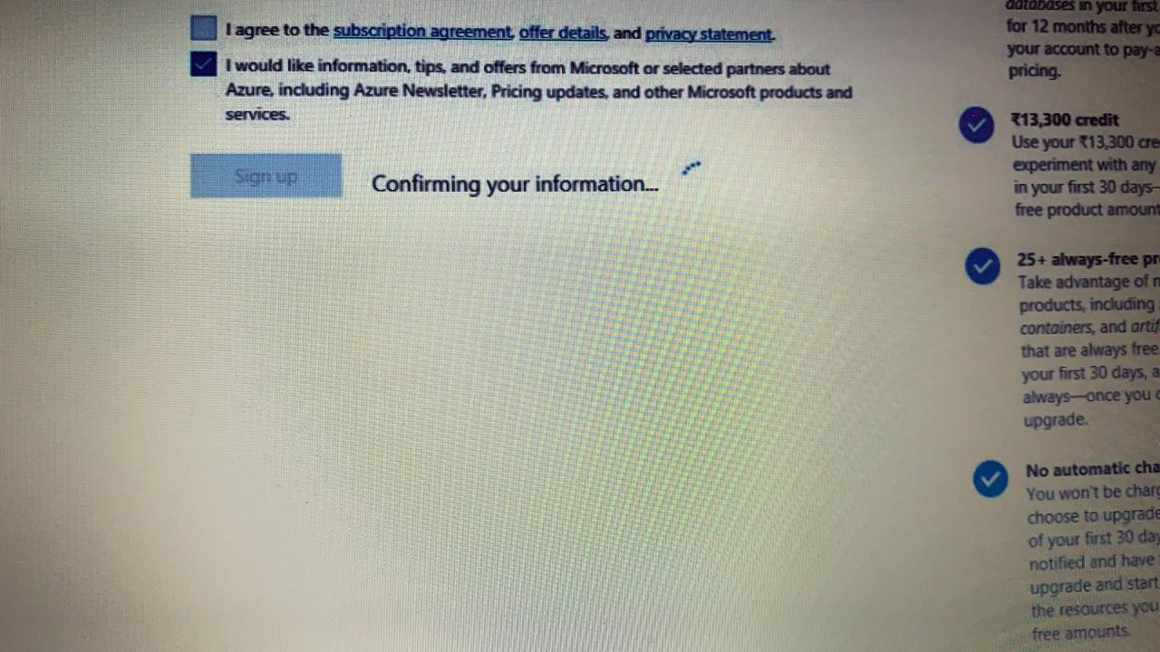

**STEP-6:**

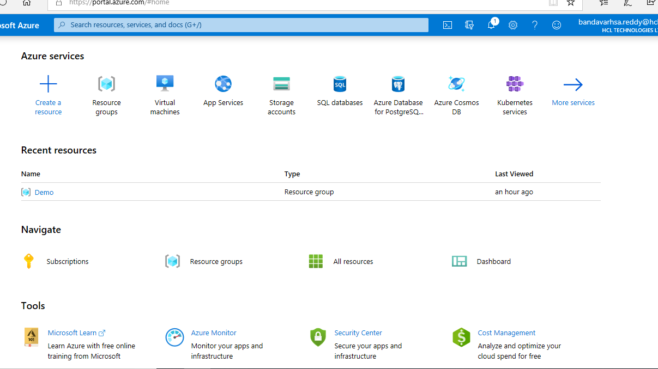

**STEP-7:**

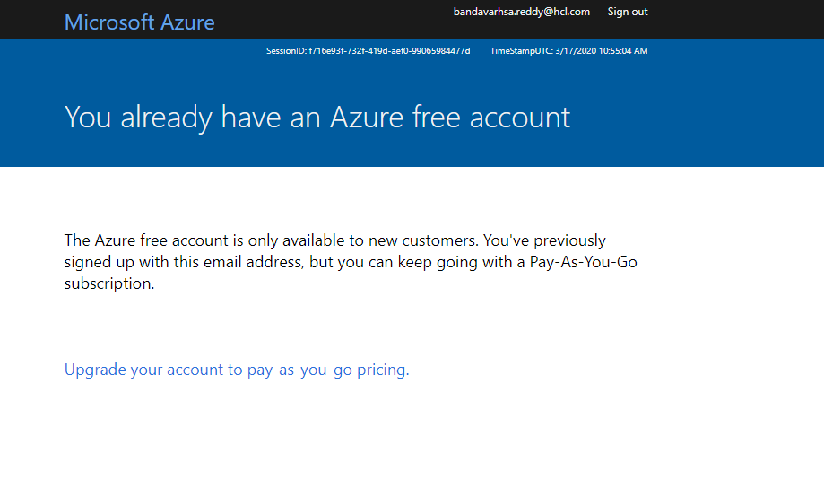

**LAUNCHING A REDHAT LINUX MACHINE USING AZURE ACCOUNT:**

**STEP-1:** Type for virtual machine in your azure account.

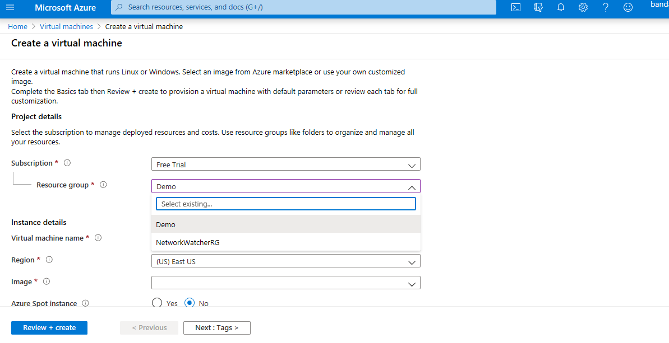

**STEP-2:**

Here you can either use existing **resource group or create new resource group**.

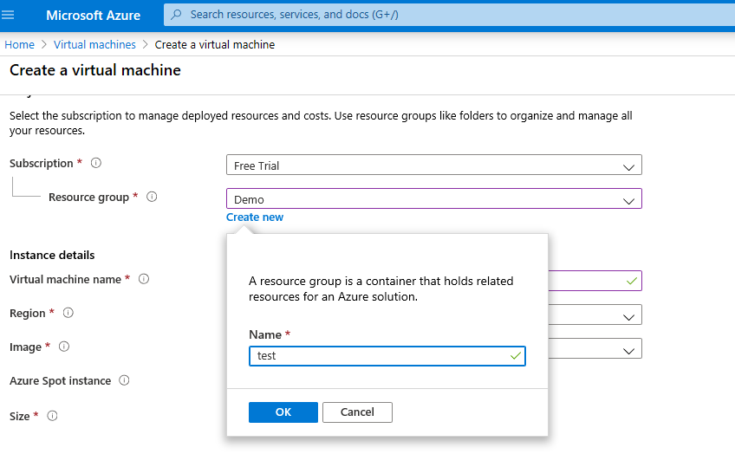

**STEP-3:** check whether 22 port number is opened or not.

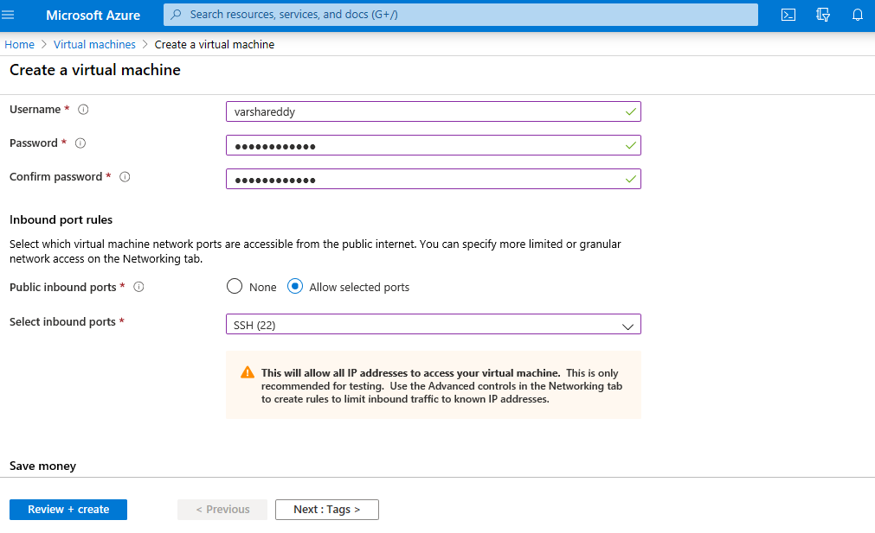

**STEP-4:** Keep the suitable disk size for launching the virtual machines.

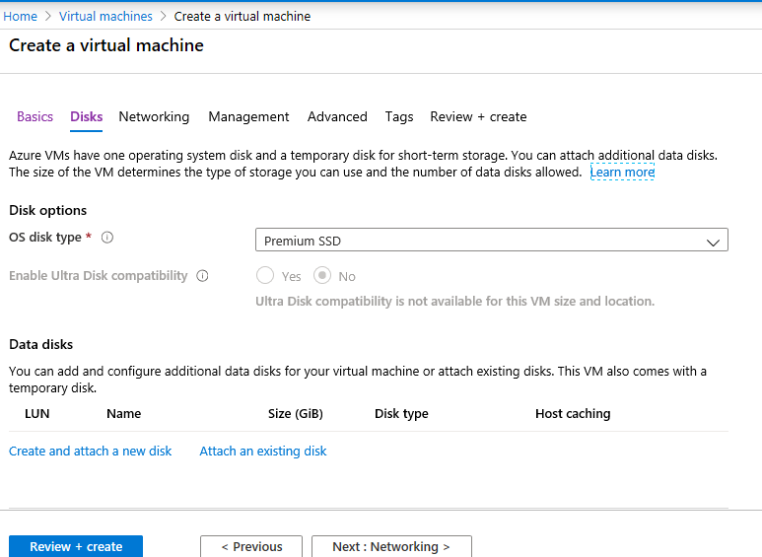

**STEP-5:** Before launching vm review an check everything.

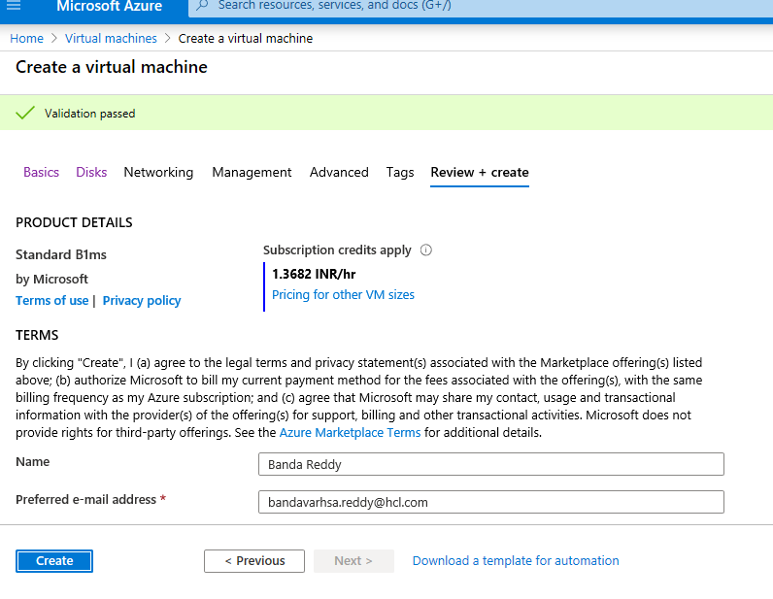

**STEP-6:** Waiting for the vm to get ready.

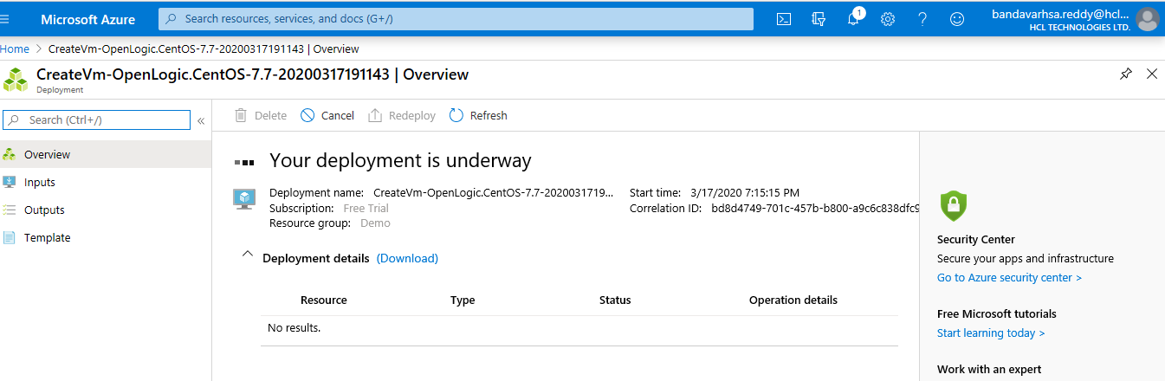

**STEP-7:** check your created vm is there in vm list or not.

